CS 255 System Design Document

UML Diagrams

UML Use Case Diagram

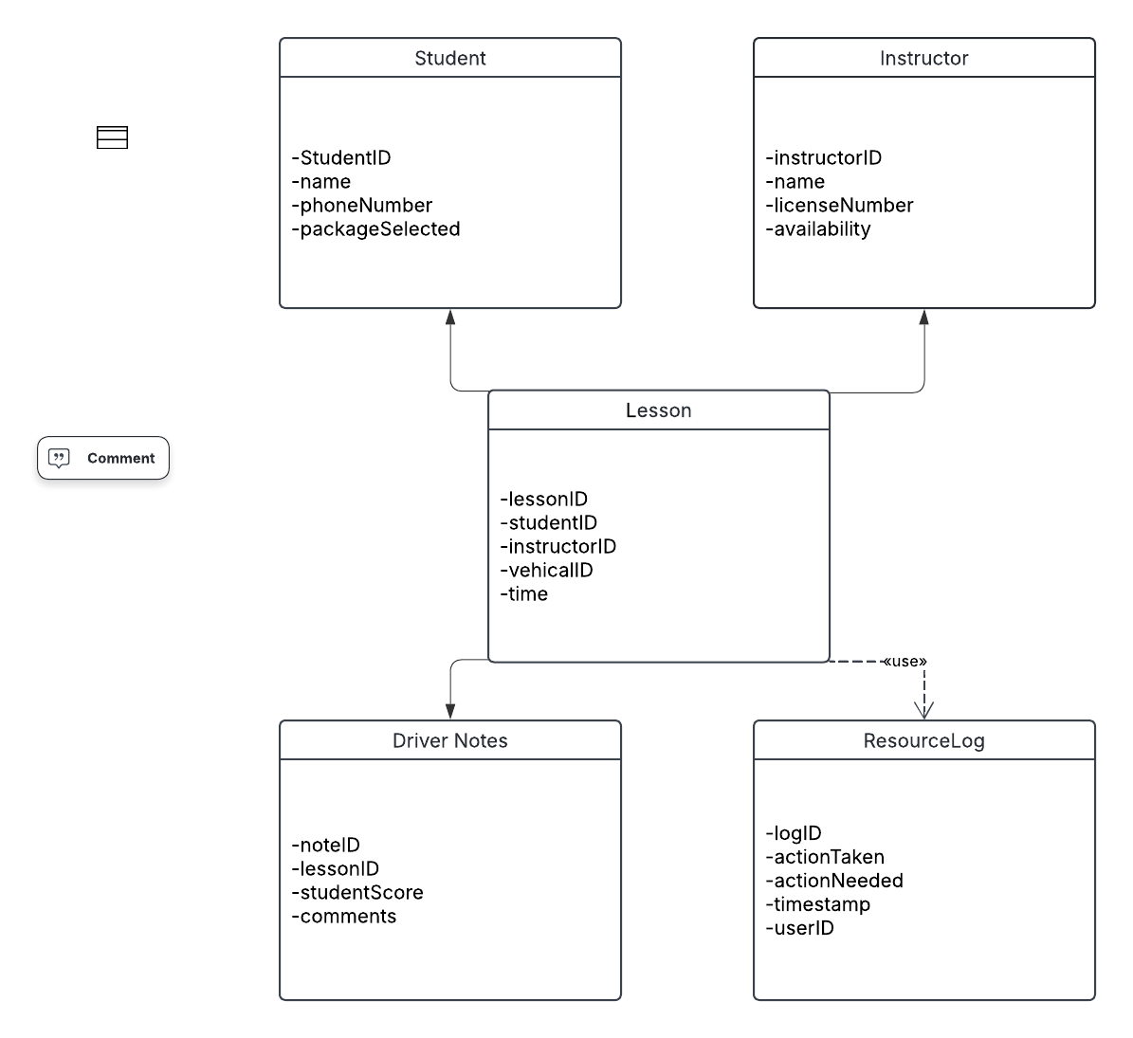

DriverPass System UML Class Diagram Summary
- Student: Tracks the primary customer data including their contact information and the specific lesson package they purchased (6, 8, or 12 hours).
- Instructor: Manages driver details, including their license information and current availability to prevent scheduling conflicts.
- Lesson: The central "hub" of the system. It links a Student to an Instructor and a specific Car for a two-hour session.
- DriverNotes: A dedicated table for instructors to record performance scores and feedback after each lesson, which feeds into the student's "Online Test Progress" dashboard.
- ResourceLog: Handles the system's auditing requirements by tracking exactly who made, modified, or canceled any record (Owner, IT, or Student).

UML Activity Diagrams

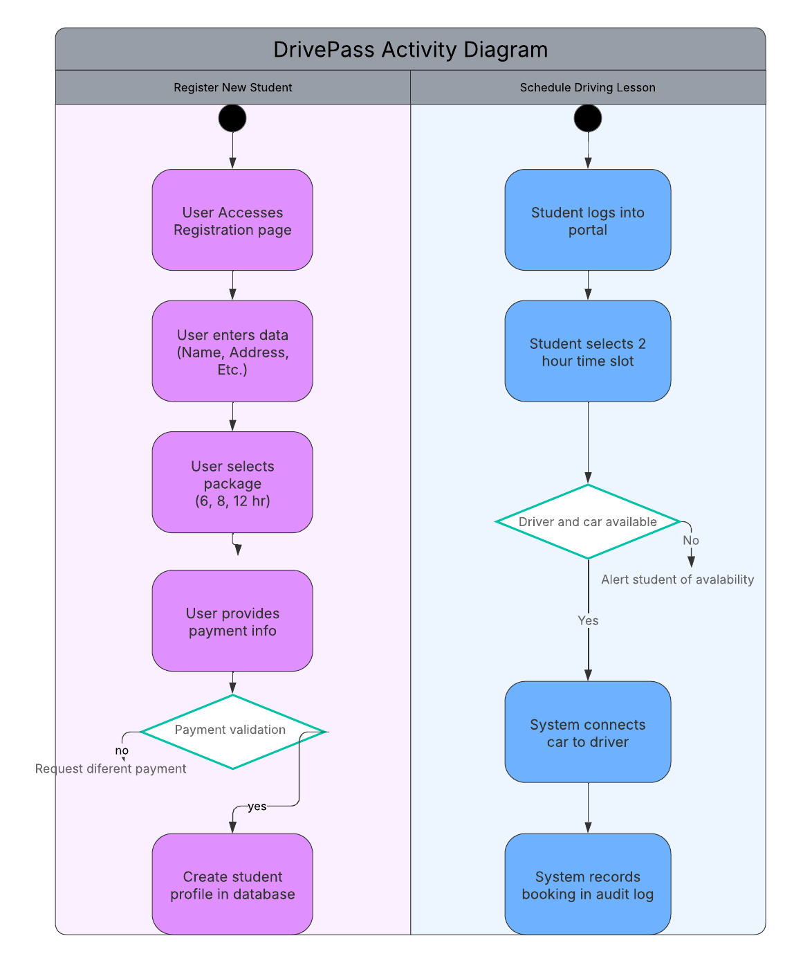

Activity A: Scheduling a Driving Lesson
This diagram illustrates the automated booking logic for the two-hour sessions linked to the fleet of 10 cars.
- Step 1: Student logs into the Self-Service Portal.
- Step 2: Student selects a 2-hour time slot.
- Decision: The system checks if one of the 10 cars and a driver are available.
- Logic: If unavailable, an alert is sent; if available, the session is linked to the resources and recorded in the audit log.

Activity B: Registering a New Student
This diagram shows the process for collecting necessary student credentials and managing package selection.
- Step 1: User enters registration data (Name, Address, Phone, Photo).
- Step 2: User selects one of the three lesson packages (6, 8, or 12 hours).
- Step 3: User provides payment information.
- Decision: The system validates payment; once successful, it creates the student profile in the database.

UML Sequence Diagram
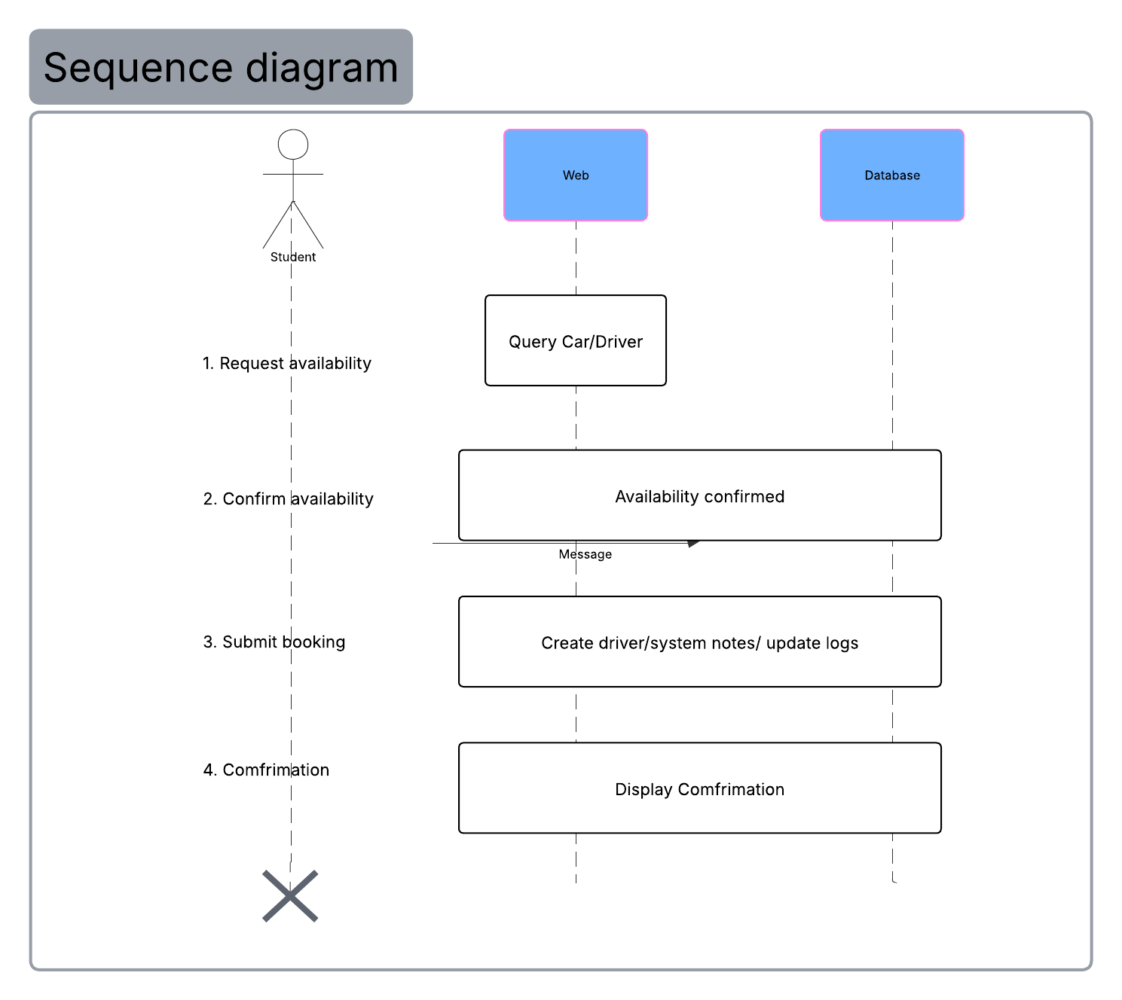

UML Class Diagram

Summary of Class Relationships:
- Student: Stores basic profile and package choice. It connects to Lesson because one student can have multiple lessons (depending on their 6, 8, or 12-hour package).
- Instructor: Stores the driver's details. It connects to Lesson to show which instructor is conducting the training.
- Lesson: The central class that links a specific Student, Instructor, and Car (from the fleet of 10) at a specific StartTime.
- DriverNotes: Linked directly to the Lesson. This is where the instructor logs the student's performance score and comments, satisfying the requirement for tracking "online test progress."
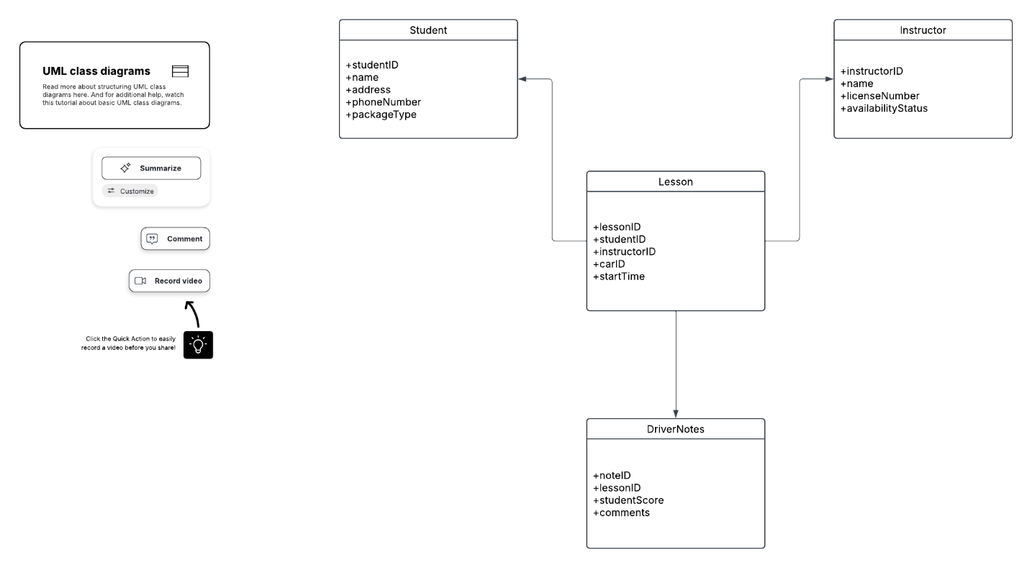

Technical Requirements

Technical Requirements for DriverPass System
1. Infrastructure & Hosting
- Cloud-based Architecture: To support the requirement for 24/7 access from any location, the system will be hosted on a cloud platform (e.g., AWS, Azure, or Google Cloud). This ensures scalability as the student base grows.
- Web Server: A high-availability web server to host the Self-Service Portal for students and the management dashboard for Liam.
2. Software Requirements
- Operating Systems: The system must be cross-platform, functioning on Windows, macOS, iOS, and Android via modern web browsers (Chrome, Firefox, Safari, Edge).
- Application Logic: Built using an object-oriented language (like Java) to reflect the classes defined in your UML Class Diagram (Student, Instructor, Lesson).
- API Integration: A dedicated integration module to connect with the DMV servers. This allows for real-time rule updates and automated practice test synchronization.
3. Database Management (The "Data" Layer)
- Relational Database: A SQL-based database (such as MySQL or PostgreSQL) to manage the complex relationships between students, instructors, and the 10-car fleet.
- Constraint Implementation: As per your specific standards, all character fields (Names, Addresses, Phone Numbers) will be set to a maximum of 75 characters to ensure data consistency and prevent truncation.
4. Hardware Requirements
- Server-Side: Managed cloud instances with enough RAM and CPU power to handle concurrent scheduling requests from multiple students.
- Client-Side: No specialized hardware is required for users; a standard smartphone, tablet, or laptop with internet connectivity is sufficient.
- Fleet Tracking: While not requiring GPS hardware initially, the system requires a data entry terminal (tablet or smartphone) for instructors to log Driver Notes immediately after a lesson.
5. Tools & Security
- CASE Tools: Lucidchart will remain the primary tool for updating and maintaining the system’s UML documentation and architectural blueprints.
- Security Protocols: * SSL/TLS Encryption: For all data in transit, especially payment and personal registration info.
  - Role-Based Access Control (RBAC): To enforce the security rules where Students, Instructors, and Owners have different permissions levels (as seen in the Use Case diagram).
  - Audit Logging: An automated logging tool to record every transaction (booking, cancellation, or DMV update) for accountability.

